**ReactJS Form Validation**

**Objective**: To create a ReactJS application that allows users to input their age in a text box and display an error message if the inputted **Age must be greater than 18**, or else display the inputted age if it is 18 or above.

**Requirements**:

1. Create a ReactJS project using create-react-app command.
2. Create a form component that includes a text box for inputting age and a submit button.
3. When the user clicks the submit button, validate the age input. If the age input is less than 18, display an error message "**Age must be greater than 18**" below the submit button.
4. If the age input is 18 or above, display the inputted age in a message below the submit button.
5. Style the form and the error/success message using CSS.
6. Add proper comments to the code.
7. Test the application by entering different age values and check if the validation and message display works as expected.

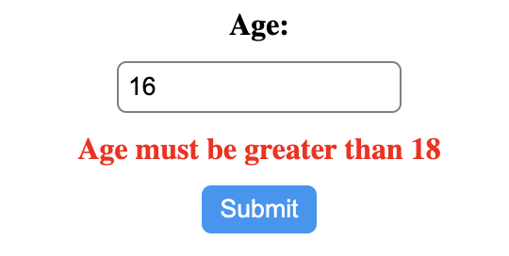

Submission:

1. Submit the code files including HTML, CSS and JavaScript files.
2. Submit a screenshot of the application displaying an error message and an inputted age.
3. Include a brief description of the project and how it works.

Note: You can use any other additional libraries for form validation.

**Use below css**

form {

display: flex;

flex-direction: column;

align-items: center;

gap: 10px;

}

label {

font-weight: bold;

}

input {

padding: 5px;

border-radius: 5px;

border: 1px solid gray;

}

button {

padding: 5px 10px;

background-color: #2196f3;

color: white;

border: none;

border-radius: 5px;

cursor: pointer;

}

.error {

color: red;

font-weight: bold;

display: none;

}